Motley Zoo’s Strut Your Mutt Event
16725 Cleveland St • Redmond WA 98052 • Email: info@motleyzoo.org

2020 DONATION FORM
(Please type or use blue or black pen)

Volunteer | NAME: | PHONE:

Donor Information:
BUSINESS/DONOR NAME – FOR CATALOG: (As it should appear in catalog)

DONOR CONTACT NAME: |  | DONOR ADDRESS:
PHONE |  | CITY: STATE: ZIP:
EMAIL (This is how we will send you your receipt. Please Print Clearly)

Item Information:
ITEM: |  |  | ESTIMATED DOLLAR VALUE:
ITEM DESCRIPTION – INCLUDE QUANTITY, SIZE, COLOR, NUMBER OF PERSONS, DAYS /NIGHTS AND ANY RESTRICTIONS:

MARK APPROPRIATE BOX:  ___ Delivery of item by Donor ___Donor provides Certificate  ___ Item needs to be picked up ___Committee to create Certificate  ___ Promotional material provided by Donor |  | SIGNATURE |  | DATE:

For office use only:
TRACKING NUMBER: | NOTES:

PLEASE RETURN YOUR DONATION FORM BY 9/11/2020
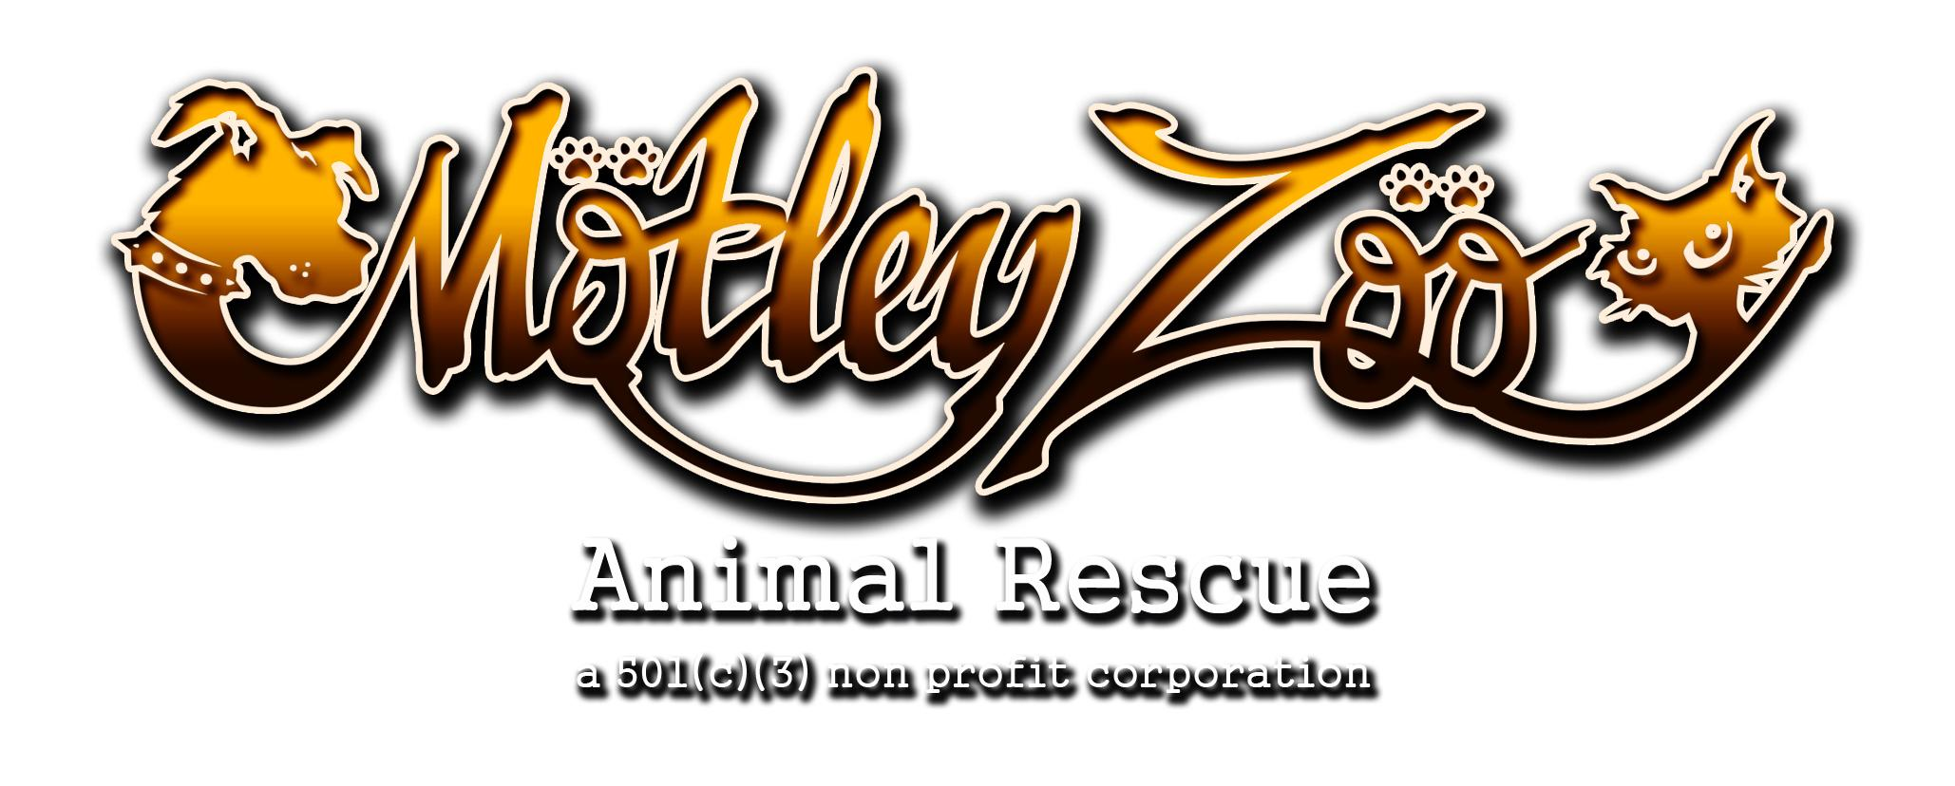
EIN# 26-4338166

